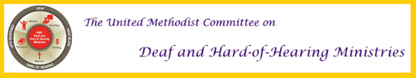
Advent Edition 2018
HOLIDAY MESSAGE
The holidays are a special time of year where our lives and our faith receive more grace, reminding one another the importance of Christ in our lives. In these busy times, slowing down, celebrating, and recognizing the importance of the Christmas message is essential for our us as individuals, for our families, for our faith communities and extended communities, and for the world as a whole. God gave us Christ as a gift. Let us share that gift with others through our faith, witness, and other expressions of our love.

The United Methodist Committee on Deaf and Hard of Hearing Ministries is grateful to you and yours for sharing, collaborating, and networking with you. Our faith has always been at the heart of our work and you being a part of it is special to us. May these Advent and Christmas seasons be full of Christ's joy, hope, peace, and love as you too witness these with others.

AVAILABLE GRANTS
Twice a year, the United Methodist Committee on Deaf and Hard of Hearing Ministries accepts grant applications for churches and ministries that supports the work of Deaf ministries. The next grant cycle is in January. Funding is limited at this time, but we encourage churches and ministries in this work to apply for a grant. Here is a link (www.umdeaf.org/fund.html) to the webpage for more information. Grants can be used for accessibility, new ministry programs related to Deaf ministries, missional reasons, empowering Deaf leadership (like trainings), and the such. Please contact Rev. Leo Yates, Jr. for any questions or assistance by emailing him at leoyjr@gmail.com.
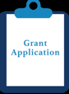

THANK YOU FOR GIVING
We are grateful for those who have made financial contributions on Giving Tuesday. The donations we received, while being tax deductible, do go a long way to help us provide resources for church and ministry programs to do ministry and missions that supports the inclusion, empowerment, and training of Deaf, hard of hearing, late-deafened, and Deafblind persons and their families.

DEAF-FRIENDLY CHRISTMAS EVE SERVICE
Quick ideas include:
* Reserve a sign language interpreter 2-3 weeks before December 24th.
* Promote having an interpreter on church signs, the church website, and in the worship bulletin.
* Do NOT dim the lights all the way when using candles, as Deaf people need to see the interpreter or handouts.
* Learn a few Christmas signs in ASL (e.g. Merry Christmas).
* Invite the children's choir or youth choir to sign a Christmas carol.
* Perform a Biblical drama, as it's visual.
* Have multimedia be a part of worship, as it makes it easier to follow the service.
* Be sure to use a sound system with a microphone and/or offer an assisted listening system. This helps make the service more accessible for hard of hearing persons.

Hard of Hearing Accessibility  Ways to increase accessibility include:  • Being near the preacher or speaker (e.g. to read lips & see facial expression)  • Use a shared microphone  • Have plenty of light (instead of a candle light, try dimming the lights)  • Offer handouts  • For non-signing individuals, offer a copy of the sermon  • Be welcoming | Deaf-Blind Accessibility  Ways to increase accessibility include:  • Transportation to & from the church  • Offer a guide or a support service provider to get around the church  • Offer large print bulletins and materials (18 point font or larger. Ask for preference.)  • Allow extra time to explore the altar or scene (e.g. feel materials or sculptures)  • Be friendly (e.g. shaking his/her hand)

LEARN CHRISTMAS-RELATED SIGNS
During Advent, take a moment each Sunday and teach a sign or two to the congregation. This shows how your congregation is inclusive and welcoming to Deaf and hard of hearing persons. Sunday School classes will love learning these Christmas signs as well.

Extended Video
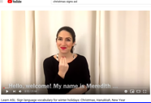
www.youtube.com/watch?v=bZoh4YNWpmI

Short Video
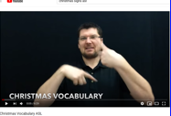
www.youtube.com/watch?v=s9JD-Tg1qCo&t=183s

LEARN CHRISTMAS SONGS IN ASL
Some Sunday School classes may be interested in learning Christmas hymns or songs in ASL. It's fun and helps to raise Deaf awareness.
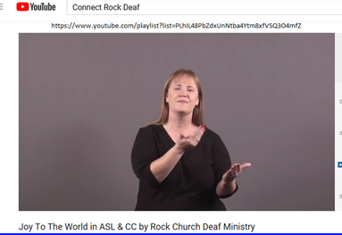
www.youtube.com/playlist?list=PLhIL48PbZdxUnNtba4Ytm8xfVSQ3O4mfZ

DEAF MISSIONS OPPORTUNITY
The United Methodist Congress of the Deaf (www.umcd.org/newssej/190811.html) is partnering with the Red Bird Mission (http://rbmission.org/work-camp/) to do Deaf missions. The mission trip to Kentucky is August 11-17, 2019 and the cost is $375 + transportation (Knoxville, TN is the closest airport). It is anticipated that other Deaf and hard of hearing persons will be attending. A $50 non-refundable deposit is due January 15, 2019. Click here (www.umcd.org/newssej/190811.pdf) for a brochure.
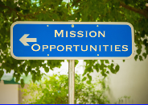

WHAT PEOPLE ARE SAYING
"I love reading the Deaf Ministry newsletters. Thank you for these. They're always so informative!"
- Rosalind McKelvey (Philadelphia, PA)

"Our recent grant from the Deaf and Hard of Hearing Ministries Committee has been so helpful. We used it to buy equipment for our Deaf ministry in which we teach ASL classes."
- Mary Ann Deters (Titusville, FL)

"The Deaf and Hard of Hearing Ministries Committee has offered our church so many new ideas. We're glad to have the support for our Deaf Ministry Sunday each September."
- Mary Harris (Orlando, FL)

"We were able to install the new assisted listening system (a hearing loop system) in our sanctuary thanks to the grant we received from the Deaf Ministries Committee. Thanks for all you do!"
- Prospect UMC (Prospect, OH)

Check out our Deaf and Hard of Hearing Ministries website at www.umdeaf.org.
Follow us on Facebook
Follow us on Pinterest
Follow us on Twitter

