To share Jesus’ love by equipping and advocating access through effective communication and leadership among the diverse Deaf, Hard-of-Hearing, Late-Deafened, and Deaf-blind communities.
---------------------------------------------------------------------------------------------------------------------
Deaf Ministries Conference
For the first time among United Methodists, a Deaf Ministries conference will be held in Las Vegas, NV. The conference is planned for July 26 – 29, 2018. Similar to previous Deaf Ministry conferences, it will include worship, networking, and sharing the best practices of doing Deaf ministry from around the country. The Deaf Ministries conference is a part of the ELM collaboration: the Episcopal – Lutheran – Methodist churches. It is not too late to register for the event. It will be held at the Tuscany Suites and Casino. The three denominations will be hosting their own meetings prior to the conference. A United Methodist Lay Servant training is being held Monday, July 23 & 24 (the basic/introductory training). The United Methodist Committee on Deaf and Hard of Hearing Ministries (DHM), a committee of the United Methodist agency, Global Ministries, is meeting on July 25. The United Methodist Congress of the Deaf (UMCD), an approved United Methodist caucus, is meeting on July 26. Click here to register for the event. Space is limited. See you in Las Vegas!
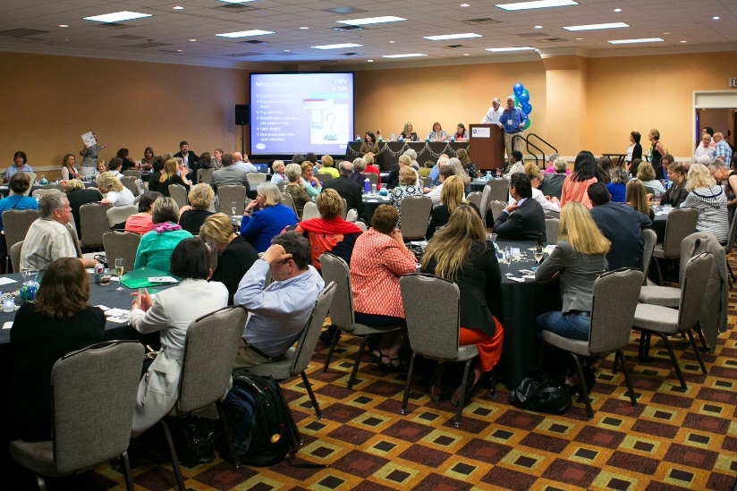
---------------------------------------------------------------------------------------------------------------------
Deaf Ministry Best Practice - Training
This quarter’s Deaf Ministry best practice is the importance of training. Participating and receiving periodic training helps individuals to sharpen their skills and gifts (for ministry). It also helps new people to learn and join servant ministry opportunities. A part of any church-related training is best practices and/or empirically studied effective techniques. For instance, being trained in Deaf ministry is helpful for hearing churches, which will enable opening their faith community to Deaf, hard of hearing, late-deafened, and Deafblind people. A specific training, for example, might be a Supported Service Provider (SSP) training so the church may be more open and welcoming to Deafblind people. In Las Vegas, the United Methodist Committee on Deaf and Hard of Hearing is sponsoring a Certified Lay Servant training for Deaf and hard of hearing people. It is being held on July 24 and 25 at the Tuscany Suites and Casino. For more information or to register for the CLS training, contact Carol Stevens at carolstevens100@hotmail.com.
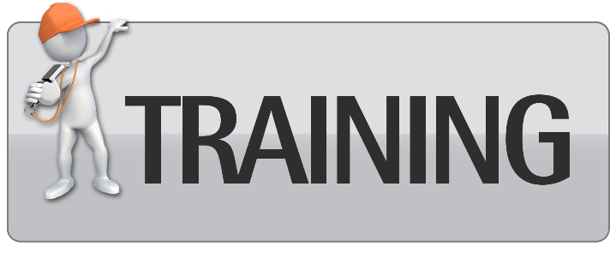
[Image description: clip art of a person pointing to the word TRAINING.]
---------------------------------------------------------------------------------------------------------------------
Interpreted Ministry Best Practice – Studying Scripture
This quarter’s interpreted ministry best practice emphasizes studying Scripture. Some may say that interpreting in a church setting is challenging, in part, because of the various venues interpreters provide services, such as worship, music, meetings, pastoral counseling, social services, weddings, funerals, dramas, and so on. For most of these venues, Scripture is often read (signed). Sometimes, the interpretation can be glossed (word for word); however, the Scriptural meaning may need to include an expansion technique in order for the message to be clear. For example, in the Hebrew Bible (Old Testament), Scripture explains how Assyria attacked Israel. If studying this scriptural passage, one will see that Assyria is northwest of Israel and the interpreted message can add that element (coming southward to Israel). This provides additional clarity to the interpretation. Study methods can include studying maps, looking at lists, looking at patterns and repetitions, commandments and blessings, comparing 2 or more Bible translations, and studying the person(s) (characters).
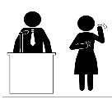
ASL Tutoring
The United Methodist Committee on Deaf and Hard of Hearing Ministries is offering free ASL tutoring to churches that do not yet have a Deaf ministry. ASL (American Sign Language) tutoring is being offered to help raise Deaf awareness and foster interest in learning in ASL. This is offered via Skype, FaceTime, or Zoom. The ASL tutoring includes practicing the manual alphabet (the ABCs), an introduction to sign phrases, introduction to some religious/church signs (i.e. church), and an overview of Deaf culture. To sign up or to request more information, contact the Rev. Leo Yates, Jr. at leoyjr@gmail.com.
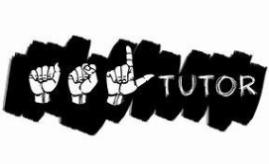
---------------------------------------------------------------------------------------------------------------------
Disability Leadership Academy
The United Methodist Association of Ministers with Disabilities is hosting a Disability Leadership Academy: Taking Our Place at the Table. It will be held at the Kellogg Conference Hotel (on Gallaudet University campus) in Washington, DC from August 1 - 3, 2018. This conference is designed to bring us together for training, conversation and strategic thinking. Click here [www.umdisabledministers.org/meeting/2018.html] for more information.
---------------------------------------------------------------------------------------------------------------------
Consultation and Trainings
Part of the work of the United Methodist Committee on Deaf and Hard of Hearing Ministries is to provide consulting and trainings for United Methodist churches. If your church is considering implementing a Deaf ministry, then contact Rev. Leo Yates, Jr. at leoyjr@gmail.com. He or one of the committee members can assist your church or ministry.
TRAININGS INCLUDE:
* Promoting Your Deaf Ministry * How to Begin a Deaf Ministry
* Overview of Deaf Ministry Models * Best Practices & Strategies
* Signing Music and Christian Dramas * Sign Language Interpreting
---------------------------------------------------------------------------------------------------------------------
Congregational Resource: Bulletin Inserts
The United Methodist Committee on Deaf and Hard of Hearing Ministries has created new bulletin inserts for download. Bulletin inserts can be used to highlight deaf awareness, to educate parishioners about Deaf culture and sign language, and/or be a part of disability-related awareness efforts. Bulletin inserts offered for download are:
- Basic Facts on Hearing Loss
- Types of Hearing Loss
- Communication Tips with Hearing Loss
- American Sign Language
- Common ASL Signs
- Symptoms of Hearing Loss
Brochures are also available for download (use regular paper or 28lb paper).
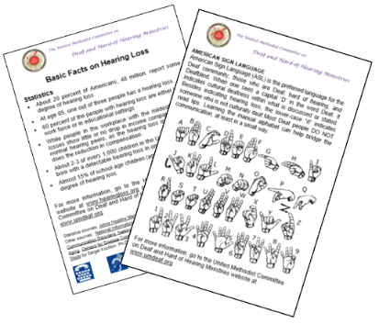
[Image description: Image of 2 bulletin inserts.]
---------------------------------------------------------------------------------------------------------------------
Deaf Ministry: A Closer Look
Trinity United Methodist Church in McMurray PA, has a Deaf outreach as a part of their ministry focus. Their April focus was a sign-a-thon held at Robinson Center Mall. Trinity UMC offers an interpreted ministry at the 9:30am Sunday worship service. Interestingly, the church wishes to bridge their Deaf ministry to the Deaf community and let Deaf and hard of hearing people know they have a place to worship. The church’s disability awareness committee, planning their Disability Awareness Sunday, reached out to Caleb, a church member and sign language interpreter to provide interpreting services that special Sunday. God used this to generate an idea that began a new Deaf ministry that includes an interpreted ministry and offering ASL classes. Helpful in this work are the church’s leadership supporting the Deaf ministry, and parishioners embracing the ministry. Communication accessibility is important; therefore paper and pens are available for brief interactions when an interpreter is not around or is busy. Visit Trinity Church’s website to learn more.
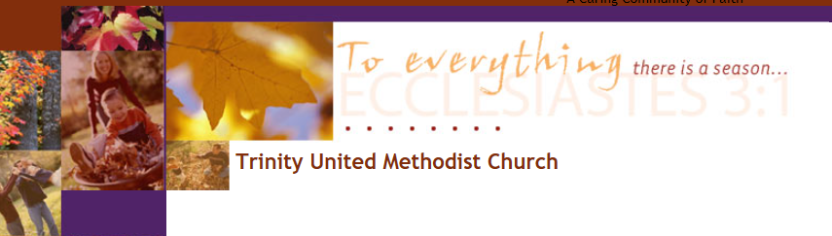
To have your church or ministry highlighted in a future newsletter, please contact
Rev. Leo Yates, Jr. at leoyjr@gmail.com. We would love to hear from you.
---------------------------------------------------------------------------------------------------------------------
Ministry Ideas!
Faith Point United Methodist Church in Frederick, Maryland offers an online worship experience called Faith Point Online. They received a grant from the Deaf and Hard of Hearing Ministries Committee and now have their worship videos captioned. By offering captioned worship and sermon videos, they are able to make them accessible for Deaf and hard of hearing individuals, particularly those who rely on captioning, as opposed to a sign language interpreter. Creative, yet accessible! The captioning service they use is Rev.com, which offers a variety of services, including captioning. Typical pricing is $1 a minute with a 24 hour turn around service. The church has a website and also a YouTube channel that hosts their captioned videos.
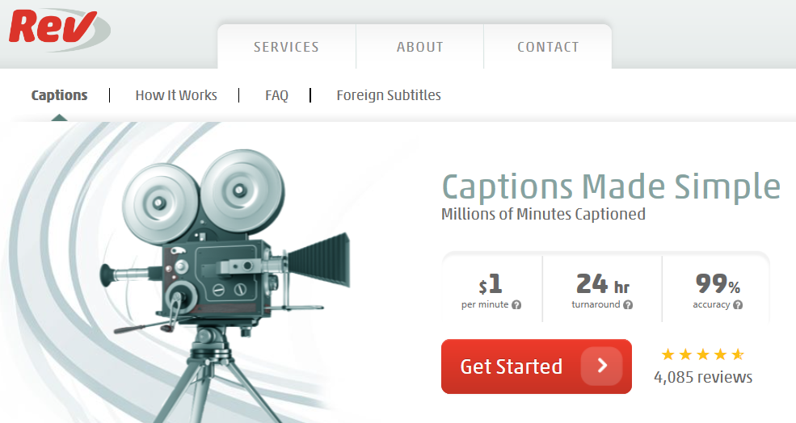
---------------------------------------------------------------------------------------------------------------------
Quick Links
DisAbility Ministries Committee of the UMC

The VOICE of the United Methodist Disability Connection
(Newsletter)

UM Association of Ministers with Disabilities

UM Committee on Deaf and Hard of Hearing Ministries

Donate through The Advance
Newsletter Archives

