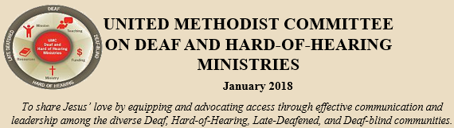
In this issue: * Headlines: New/updated resource * Best Practices of Deaf Ministry *
* UMCD News * Best Practices of an Interpreted Ministry * Be Accessible *
* Congregational Resource * Deaf-friendly Worship Tip

Headlines
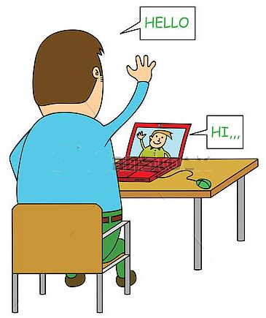
The United Methodist Committee on Deaf and Hard of Hearing Ministries is offering ASL tutoring to churches. ASL (American Sign Language) tutoring is being offered to help raise Deaf awareness and foster interest in learning in ASL. The ASL tutoring is FREE, which will include practicing the manual alphabet (the ABCs), an introduction to sign phrases, be shown some religious/church signs (i.e. church), and an overview of Deaf culture. The ASL tutoring program will be for United Methodist churches that do not have a Deaf ministry. The Rev. Tom Hudspeth, the president of the Committee on Deaf and Hard of Hearing Ministries, said, “We’re glad to be able to offer this ASL tutoring program to adults and hope it will spark an interest in building relationships with Deaf, hard of hearing, late-deafened, and Deafblind people.” Using platforms like ZOOM, FaceTime, or Skype is how the ASL tutoring will take place. To sign up or to request more information, contact the Rev. Leo Yates, Jr. at leoyjr@gmail.com.
Learn how to sign through ASL Tutoring
via FaceTime, Skype, or Zoom.

Deaf Ministry Best Practices
This issue’s Deaf ministry best practice is mediating conflicts. First, all ministries have some sort of conflicts. By not mediating/resolving conflicts, visitors and guests will likely see them, which can prevent them from returning. Even Jesus talks about this.
Matthew 5:23-24 (MSG)
²³⁻²⁴ “This is how I want you to conduct yourself in these matters. If you enter your place of worship and, about to make an offering, you suddenly remember a grudge a friend has against you, abandon your offering, leave immediately, go to this friend and make things right.”
How do you resolve conflicts? Pray – Talk – Listen – Forgive. Sometimes this will be a short term solution and it needs to be repeated due to a person’s personality (even Jesus experienced personality conflicts with his inner circle of friends). The basic principle of mediating conflicts comes from Jesus’ command of forgiving one another (Matthew 6:14-15). Not surprising, sometimes individuals will not come together to talk and (sadly) some leave altogether. This is where prayer (sometimes a lot of it) is needed.
Let’s Be Friends

Pray

Talk

Listen

Forgive

Check Out…
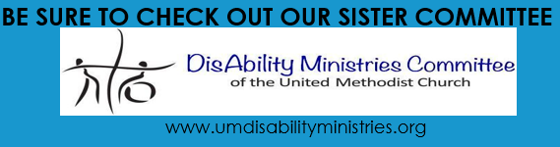

Interpreted Ministry Best Practices
Having a list of go to religious interpreting resources is this quarter’s best practice. Sometimes, the resource may be for interpreters, but sometimes it may be for others, whether they are interpreting colleagues, nascent interpreters, or those interested in sign language. Here are a few resources for your resource library:
* ASL Interpreting (a variety of resources)
* ASL Pro: Religious Signs
* Interpreting at Church: A Paradigm for Sign Language
Interpreters, 4th Edition (Amazon.com)
* ASL Bible
* The Interpreter’s Friend
(both Jewish and Christian traditions)
* The ASL Glossary (The United Methodist Church)
* Start ASL (an online sign language class)

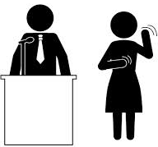

Congregational Resource
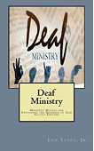
Looking for a guide to Deaf Ministry? Consider, Deaf Ministry: Ministry Models for Expanding the Kingdom of God, 2ND Edition (available on Amazon.com). It includes updated and expanded chapters. New are best practices and strategies, promoting the ministry, hospitality ideas, advice for hosting a Deaf Awareness Sunday, guidelines for implementing a Deaf ministry committee, typical responsibilities for a Deaf ministry coordinator, ideas for recruiting interpreters, and suggestions for starting a sign choir and a Christian drama group, and more. Remember, at the heart of any ministry are prayers and relationships.

UMCD News
The United Methodist Congress of the Deaf (UMCD) is happy to report that they are co-sponsoring a conference in Las Vegas, Nevada this summer. As a part of the ELM (Episcopal – Lutheran – Methodist) initiative/collaboration, a conference is being planned by St. Matthew’s Evangelical Lutheran Church (from California) to bring together Deaf, hard of hearing, late-deafened, Deafblind, and hearing members from the three denominations (ELM). The conference will be held at the Tuscany Suites and Casino and the dates will be held from July 26 – July 29, 2018 (check out Sunday morning). Each denomination will hold meetings prior to the conference and individuals and families are welcome to come earlier. UMCD’s meeting is July 25 – July 26 (best to arrive on July 24). If interested, there is a special certified lay minister training being held from July 22 – 24.
* Certified Lay Servant Training July 22-24
* UMCD business meeting July 25-26
* ELM Conference July 26-29
Some people will be interested in going earlier to
attend or support these meetings for the entire week.
There will be special speakers, workshops, information
sessions, and so on. To receive the special hotel price,
register through the conference (not through the hotel). For registration information,
visit the UMCD website or contact Rev. Tom Hudspeth at thudspeth@llumc.org. Early bird deadline is February 28, 2018.

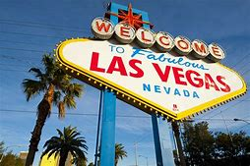

Deaf-friendly Worship Tip
This quarter’s Deaf-friendly Worship Tip is including the manual alphabet in the worship bulletin or on the back cover of the bulletin. Even putting up a poster or two in popular areas of the church is a good idea. The reasons behind this are: (1) it can help someone in a pinch, (2) spark an interest in sign language, (3) show Deaf people (and their language) they are important, and (4) encourage others to communicate with Deaf and hard of hearing people attending church (Deaf people want to make friendships beyond the interpreter). Many seniors are losing their hearing. According to the Center for Hearing and Communication:
* 14% of adults between 45-64 years have
hearing loss.
* 1 in 3 seniors over the age of 65 have some
type of hearing loss.
* 2 out of 3 seniors over 75 have hearing loss.
Be proactive and encourage learning a second
language and help remove any stigma with
deafness by normalizing the need to learn sign
language. Just google ASL alphabet and identify
one that includes numbers as well. Bulletin Insert

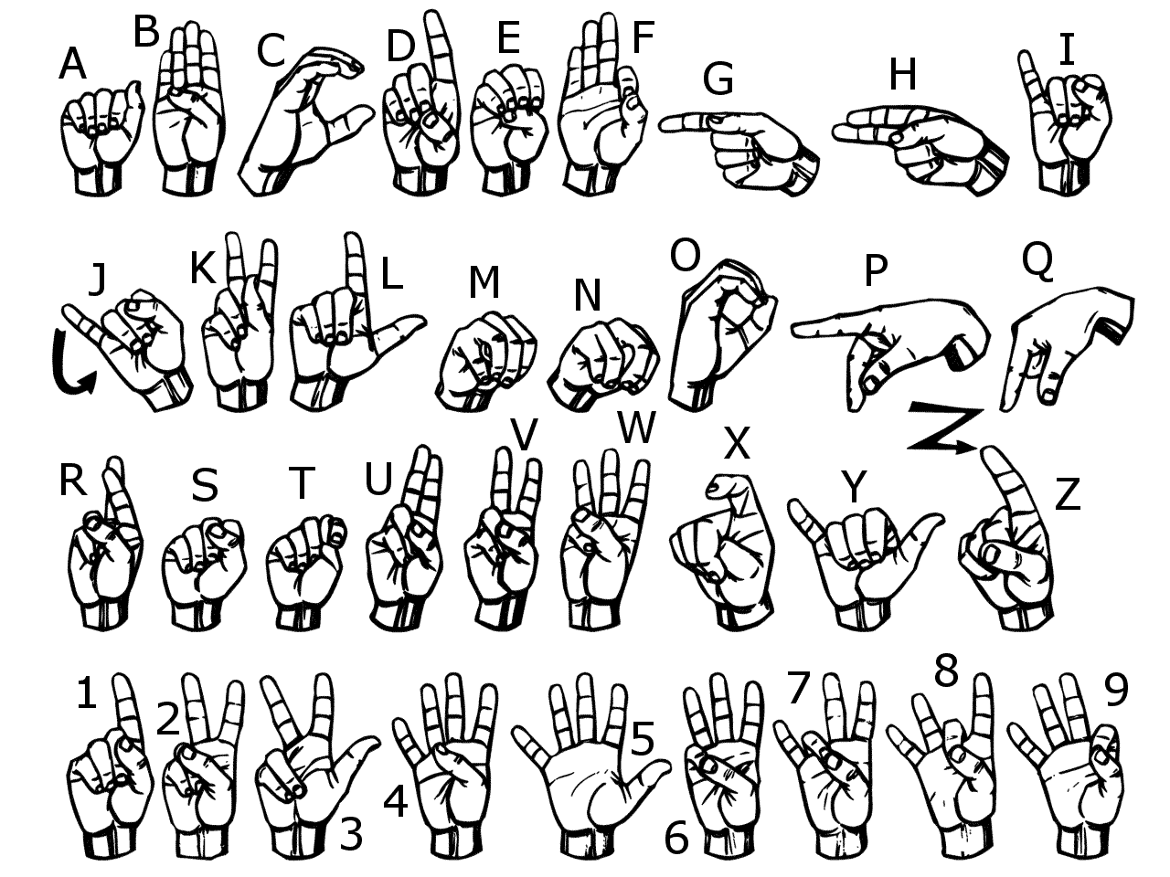

Follow Us on Social Media
Check out our Deaf and Hard of Hearing Ministries website and
Follow us on Twitter
Follow us on Facebook.
Follow us on Pinterest.
The United Methodist Committee on Deaf and Hard of Hearing Ministries is a committee of Global Ministries.

