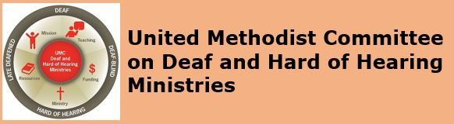
[Image Description: United Methodist Committee on Deaf & Hard of Hearing Ministries and its logo]

Monthly E-News
May 2019

GRANTS AVAILABLE
The Deaf and Hard of Hearing Ministries Committee are accepting grant applications. There are limited grants available for up to $5,000. Grants are expected to have a community impact. Also, grants are for new ministry programs/projects (not already established ministries) and are to be completed in 2019. Existing Deaf ministries may apply if they are expanding or enhancing their ministry in new ways. Grant applications are due by the end of June. Some ideas include, but are not limited to, are:
Deaf Ministry Idea #1
- Interpreting Ministry (ex. interpreting services for worship)
- Improved accessibility (ex. assisted listening system for the fellowship hall)
- Connecting to a nursing home (ex. extending the worship community)
- Music ministry (ex. a new sign choir for raising Deaf awareness)

Deaf Ministry Idea #2
- Family Ministry (ex. implementing parent/child sign language classes)
- Community Outreach (ex. fellowship with an assisted living facility)
- District wide ASL classes (ex. inviting other churches from your district)
- Interpreting ministry (ex. offering interpreting services for church events)

Deaf Ministry Idea #3
- Deaf mission trip (ex. a mission trip to Jamaica Deaf school)
(ex. establish an on-going partnership, bring supplies, do evangelism)

The ideas are endless. A Deaf ministry project/program budget should reflect the expenses of the grant. Contact Rev. Leo Yates, Jr. at leoyjr@gmail.com for more ideas. For more ministry ideas or to better understand the ideas above, consider reading the book, Deaf Ministry, 3rd Ed.

DEAF MINISTRY SPOTLIGHT
This issue's Deaf Ministry's spotlight is Grace United Methodist Church in Philadelphia, PA. The Deaf ministry at Grace UMC includes an interpreting ministry, a hospitality ministry, a social activities ministries, mentorships, and sign language classes. Unlike other Deaf ministries, Grace UMC has a Deaf ministry coordinator who assists with overseeing the different aspects of the ministry. To learn more about their dynamic ministry, check out the church's website.
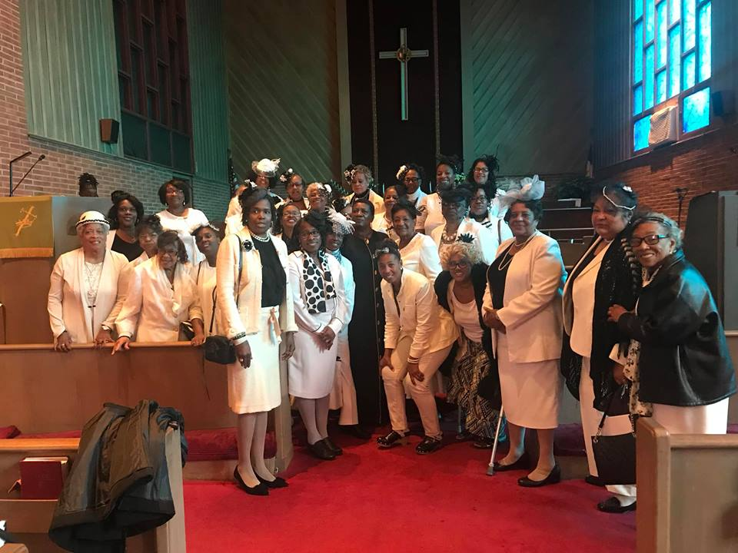
[Image Description: Deaf & hearing women gather at a church event]

DEAF MINISTRY BEST PRACTICE

This issue's Deaf Ministry best practice is having a Deaf ministry coordinator. By having a paid or a volunteer Deaf ministry coordinator, the church's Deaf ministry will be better organized, more engaged in the life of the church, and assist with the ministry’s overall work. For example, a Deaf ministry coordinator can coordinate the interpreter's schedule, plan potluck/cover dish events, promote and coordinate sign language classes, plan observances and celebrations (e.g. Deaf Awareness Week), visit or coordinate visits with Deaf shut-ins, share ministry updates or reports with church leadership, train ushers/greeters (e.g. how to sign "good morning" and where assisted listening devices are located), and so on. To learn more about a Deaf ministry coordinator position and/or having a Deaf ministry committee, consider reading Deaf Ministry: An Introduction to Ministry Models (see chapter 11). Rev. Leo Yates, the consultant of the Deaf and Hard of Hearing Ministries Committee, is available by contacting him at leoyjr@gmail.com. There are limited small grants available to hire a Deaf or hard of hearing Deaf ministry coordinator. Contact Rev. Leo Yates (leoyjr@gmail.com) for details. Grant applications for this are due by the end of June 2019.
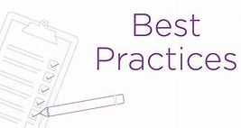
[Image Description: The words Best Practice with a check list]

INTERPRETING MINISTRY BEST PRACTICE
This issue's interpreting ministry best practice is understanding and articulating the role of a sign language interpreter. Most of the time the work of an interpreter appears seamless; however, those who provide interpreting services do a lot of preparation beforehand. The interpreter ought to be able to articulate his or her role, explain (realistic) expectations, share his or her educational (training) background, and what some of the specific knowledge an interpreter should have by serving in a Christian setting, like at a church. All of this helps the church or church leadership to better understand about the Deaf ministry or interpreting ministry, have better value the role, and emphasizes the importance of communication access. To learn more about how to best explain the role of an interpreter, check out the Registry of Interpreters of the Deaf Standard Practice Paper.
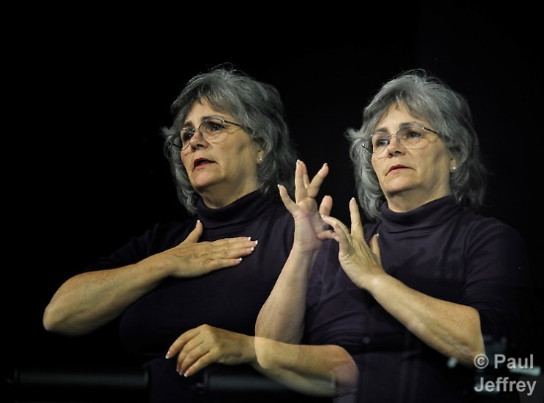
[Image Description: Interpreter Mary Harris signing my Jesus]

FOLLOW US
Follow us on Facebook
Follow us on Pinterest
Follow us on Twitter

Copyright © * 2019 * Global Ministries Committee on Deaf and Hard of Hearing Ministries *, All rights reserved. Website: www.umdeaf.org. Email questions or comments to umdeaf@gmail.com
Mailing address:
General Board of Global Ministries
Attn: Sabrina Rodgers
458 Ponce De Leone Ave NE
Atlanta, GA 30308

