United Methodist Committee on
Deaf and Hard of Hearing Ministries
Newsletter
November 2015
List of committee members:
Rev. Dr. Tom Hudspeth
Committee Consultant
Rev. Lisa Jordan
President
Rev. Leo Yates, Jr.
Vice President
Rev. Dan Bryant
General Board of Global Ministries Director
Patricia Magyar
General Board of Global Ministries – Health Liason
Bryan Branson
Western Jurisdiction
Rev. Willy Banza
Central Jurisdiction
Beverly Chesebro
Northcentral Jurisdiction
Jeff Burns
Northcentral Jurisdiction
Billy Deters
Southeast Jurisdiction
Evon Malray-Cain
South Central Jurisdiction
Sandy Saunders
Northeast Jurisdiction
Richard Stallworth
Southeast Jurisdiction
Tim Vermande
Editor
Lynn Swedberg
Disability Ministries Consultant
(NEW ARTICLE)
NEW RESOURCE
(subtitle) New Book Educates Churches about Starting a Deaf Ministry
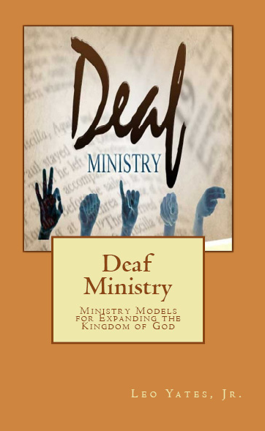
Rev. Leo Yates, Jr., a member of The United Methodist Committee on Deaf and Hard-of-Hearing Ministries, authored the book, Deaf Ministry: Ministry Models for Expanding the Kingdom of God. Rev. Yates attributes his writing to the committee’s encouragement. “I wanted to offer a resource for ministries and churches in starting their own Deaf ministry. I tried to include some suggestions and ways to access resources too.”
The Deaf ministry book offers an introduction to this specialized ministry and covers a number of ministry models that are available for churches to use in their ministry. Toward the end of the book, readers are engaged with a plethora of ways for beginning and/or maintaining a Deaf ministry program. “Ministry is more than providing accommodations,” said Yates and “the book provides ideas for being a church that provides hospitality.” The book, Deaf Ministry, can be purchased at Amazon.com.
(new article)
Deaf Ministry – Best Practices
There are a number of best practices for doing Deaf ministry. For this quarter’s newsletter, becoming familiar with Deaf culture is highlighted. Deaf culture is interwoven into each Deaf community. It includes having shared values (i.e. having a video phone), beliefs (i.e. having communication access), and experiences (i.e. attending a Deaf school) that many Deaf, hard-of-hearing, late-deafened, and Deaf blind individuals have in common. It also includes having a shared language, as well as having traditions. Study up on it today!

(new article)
United Methodist Glossary in American Sign Language
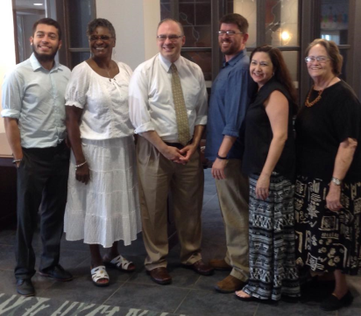
It’s here! United Methodist Communications in collaboration with The United Methodist Committee on Deaf and Hard-of-Hearing Ministries, The General Board of Global Ministries, produced a small library of United Methodist terms in ASL as a part of the denomination’s glossary. Deaf, hard-of-hearing, late-deafened, Deaf-blind individuals and their families, as well as others who are interested, are able to access the online glossary by going to www.umc.org/what-we-believe/glossary.
(New article)
Advance Giving – December 1st
On December 1, 2015, United Methodists will join hands to support the work of Advance projects and missionaries to transform lives on UMC #GivingTuesday. Every gift made online through The Advance at www.umcmission.org/Give-to-Mission/Search-for-Projects/Projects/982562 on Dec. 1, 2015 will be matched up to $1 million. Please donate to the United Methodist Committee on Deaf and Hard-of-Hearing Ministries. The Advance special number for this ministry is 982562. Global Ministries will allocate matching funds (up to $1 million) to Advance projects received online on Dec. 1, 2015, between 12:00a.m. and 11:59 p.m. CT. A maximum of $2,500 per individual gift to a project will be dispersed as matching funds and a maximum of $25,000 matching for each project.
(new article)
Interpreted Ministry ~ Best Practices
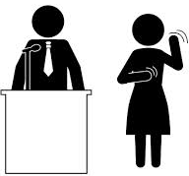
Whenever I interpret in a church setting, it is often for worship services. As one of the best practices for interpreting at church is worship preparation.
Worship preparation is not the typical of reading or scanning the music ahead of time in hopes of choosing a gloss or interpretation. It's not even studying the Scripture passage(s) so the best interpretation can be determined. Worship preparation is really about being fully present during the time of worship. Often, we enter worship with things on our minds (e.g. To do list).
By being present, we are better able to think with clarity, have a sharper focus, and deliver the message more coherently. So how does one prepare for worship? In mental health counseling/therapy, mindfulness techniques are often taught. Mindfulness helps the individual to be grounded in the present and aware of the here and now. When this occurs, we will be aware of our thoughts, emotions, and sensations. There are numerous mindfulness techniques such as the one minute breathing technique. Here, you will start by breathing in and out slowly, holding your breath for a count of six once you’ve inhaled. Then breathe out slowly, letting the breath flow effortlessly out back into the atmosphere. Literally watch your breath with your senses as it enters your body and fills you with life, and then watch it work its way up and out of your body. You are simply watching your breath enter your lungs and exiting from your lungs. Often the benefit will be immediate. This technique is a form of meditation.

As you are present to the work you are about to perform, you will be better able to slip into your interpreting role. You will be more readily available in terms of your mind, body, and spirit and your interpreting services will be better delivered. Try this one minute breathing technique for yourself.

(new article)
News from ……Northeastern Jurisdiction of the UMCD
The NEJ chapter of the UMCD held a one day conference on Saturday, October 17, 2015 in New Jersey. Members and visitors from the Greater NJ annual conference and the surrounding annual conferences met for a day of business, worship, missions discussions, and sharing of Deaf ministry ideas. The guest Deaf preacher was Rev. Chris Hughes from Frederick, Maryland.
(new article)
Grants Available
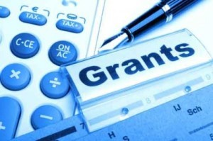
The United Methodist Committee on Deaf and Hard-of-Hearing Ministries offers grants for seed money for new ministries, domestic and international mission outreach, Deaf camps, communication access, and scholarships. To read the guidelines and to get an application, go to www.umcdhm.org/download/grant.doc.

(new article)
Free Consultation
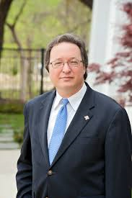
The Rev. Dr. Tom Hudspeth is the consultant representing The United Methodist Committee on Deaf and Hard-of-Hearing Ministries. This free consultation can include what resources are available, program planning, recommendations for improving your Deaf ministry, available grants, and among other needs. Rev. Tom can be reached at thudspeth@llumc.org.
(new article)
A Closer Look – Magothy United Methodist Church of the Deaf
One of the denomination’s best kept secrets is Magothy United Methodist Church of the Deaf, located in Pasadena, Maryland. This Deaf church was first established in 1975 by the efforts of Rev. Gross who was associated with the late Rev. Louis Foxwell, Sr. Rev. Gross saw the need in Pasadena for beginning a Deaf ministry. What began as a shared facilities with Magothy United Methodist Church, a hearing church, it flourished to become a chartered church in the early 1980s. A few of the original church members continue to attend Magothy and serve in various ways. Over the years, Magothy Deaf Church was instrumental in educating the Anne Arundel County Fire Department and the Anne Arundel Police Department about Deaf needs and provided Deaf sensitivity training. Also, Magothy Deaf Church has taught numerous sign language classes to the community. It has an active missions committee that works with missional needs, as well as doing fundraising. Magothy Deaf Church is located at 3703 Mountain Road in Pasadena, MD. It’s worship service is at 10:15am. Sign language interpreters are on hand to provide voice interpretation. Their website is www.magothydeafchurch.org/.
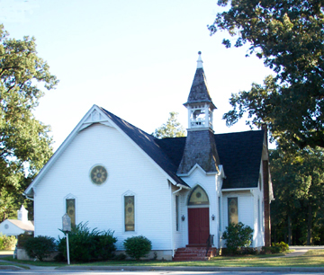
(blurb)
To have your church or ministry highlighted in a future newsletter, please contact Rev. Leo Yates, Jr. at leoyjr@gmail.com. We would love to hear from you.
(new article)
News from South Central Jurisdiction UMCD
The South Central Jurisdiction of the United Methodist Congress of the Deaf met at Asbury UMC, in Tulsa, Oklahoma, Oct 2-4, 2015. Our theme was “Increase By Service: Growing Deaf Ministries.” Our keynote presenter was Raphael “Ray” James, an instructor for the Interpreter Education Program at the University of Arkansas and life-long communicator of the Gospel in ASL. The SCJ covers the areas of Louisiana, Texas, New Mexico, The Four Corners Reservation, Oklahoma, Arkansas, Missouri, Kansas and Nebraska. Our next SCJ-UMCD will be in October 2017, hosted by the Lovers Lane United Methodist Church and Dallas Indian Deaf Ministry, Dallas, Texas. For more information, contact Michelle Martin at michbmart@yahoo.com.
(blurb)
Check out our sister committee
Disability Ministries Committee of the UMC
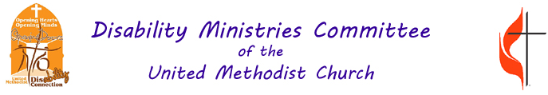

(new article)
News from the United Methodist Congress of the Deaf
The United Methodist Congress of the Deaf is holding its 2016 global gathering in St. Paul, Minnesota, at St. Catherine’s University. We will be guests of the Evangelical Lutheran Association of the Deaf, and we be joined by the Episcopal Conference of the Deaf. Events are: church worker training, July 17-20, 2016, followed by
joint worship, workshop and fellowship of the UMCD, ELDA and ECD from July 21-24, 2016. UMCD members will elect new officers on July 23, 2016 and will set goals for the organization. For more information about UMCD, go to www.umcd.org or contact Rev. Tom Hudspeth at thudspeth@llumc.org or vp 469-522-2974.
Did you know? UM-DHM and UMCD will award in July 2016, The Philip Hasenstab Award of Excellence in Deaf Mission and Evangelism, and The Daniel Moylan Award for Church Excellence in Deaf Mission and Evangelism. If you want to nominate a United Methodist church that you feel performs excellence in mission and evangelism with the Deaf, or a United Methodist lay person or clergy person who performs excellence in Deaf mission and evangelism, please submit your nomination and information about your nominee to Rev. Tom Hudspeth at thudspeth@llumc.org. Deadline for nominations is February 1, 2016. Previously awarded were Bishop Peggy Johnson and Christ Church of the Deaf UMC in 2014.

